# EPPS 6356 – Assignment 4: Chart Hackathon

This document compiles all four visualization steps completed using R and ggplot2. Each plot was executed successfully and verified in RStudio.

## Step 1: Time Series – US Unemployment Over Time

Dataset: ggplot2::economics  
This plot shows the trend of unemployment in the U.S. from 1967 onward. A blue line represents raw data, while a purple dashed loess smooth line shows long-term trends.

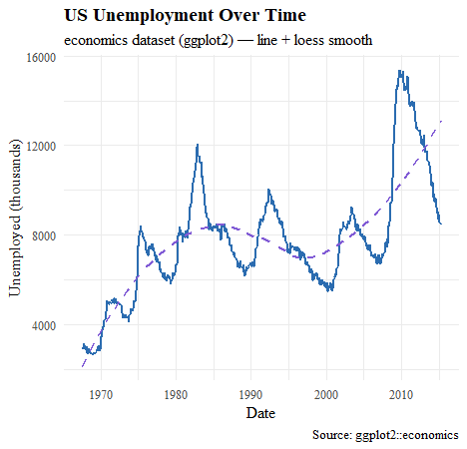

## Step 2: Scatter Plot – Fuel Efficiency vs Vehicle Weight

Dataset: datasets::mtcars  
This scatterplot demonstrates the negative correlation between vehicle weight and fuel efficiency (MPG). A green dashed regression line visually confirms the inverse relationship.

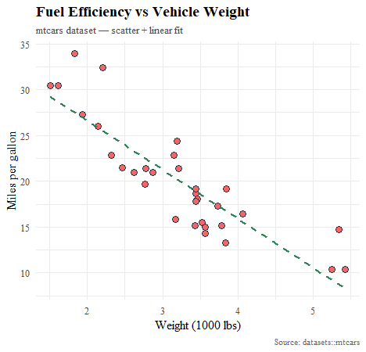

## Step 3: Faceted Plot – Petal Geometry by Species

Dataset: datasets::iris  
This faceted plot displays petal length versus petal width for three Iris species. Each facet includes its own linear regression fit, illustrating clear separability among species.

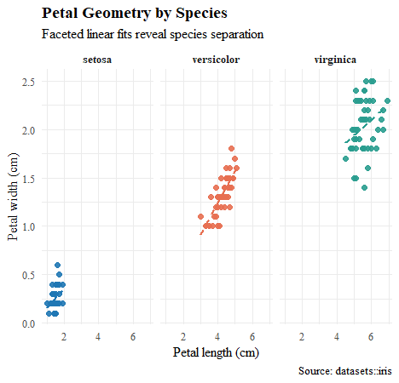

## Step 4: Distribution – Diamond Prices by Cut Quality

Dataset: ggplot2::diamonds  
This overlaid histogram uses translucent colors to show price distributions across cut categories. It highlights how premium and ideal cuts are more frequent in the lower-to-mid price ranges.

